**Root cause analysis for Invoice reversed after Material Dispatch**

1. Sale Order: 353512050 released on 22.05.2018 @ 16:20:52 for 48.300 MT, Delivery and shipments created each for dispatch quantity 16.100MT by TPVS for 48.300 MT on 22.05.2018 @ 20:53:34.

Deliveries: - 508871342, 508871345, 508871357 (16.1 each)

Shipments: - 52077784, 52077788, 52077789

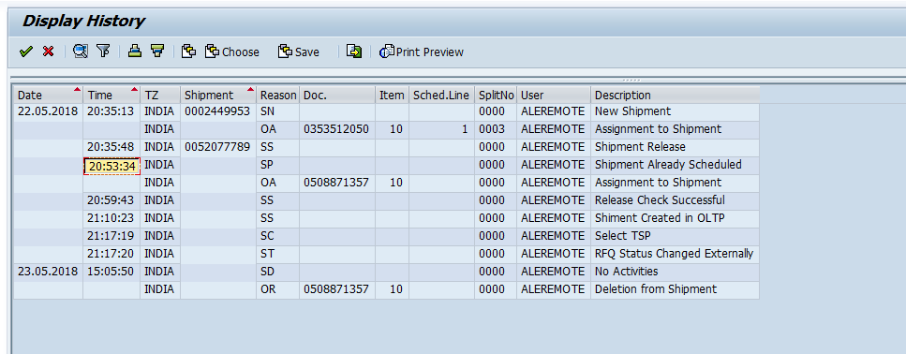

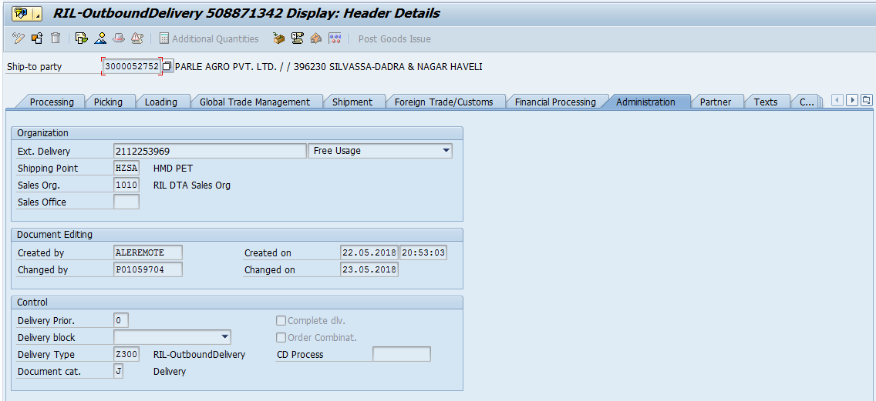

1. Shipments (52077784 with reference to reporting no: 2112253969) dispatched on 23.05.2018 @ 12:22 and Shipment (52077788 with reference to reporting no: 2112254932) dispatched on 23.05.2018 @ 18:34.

**Two shipments along with delivery dispatched properly without any issue as above. Below is the status screen of truck movement.**

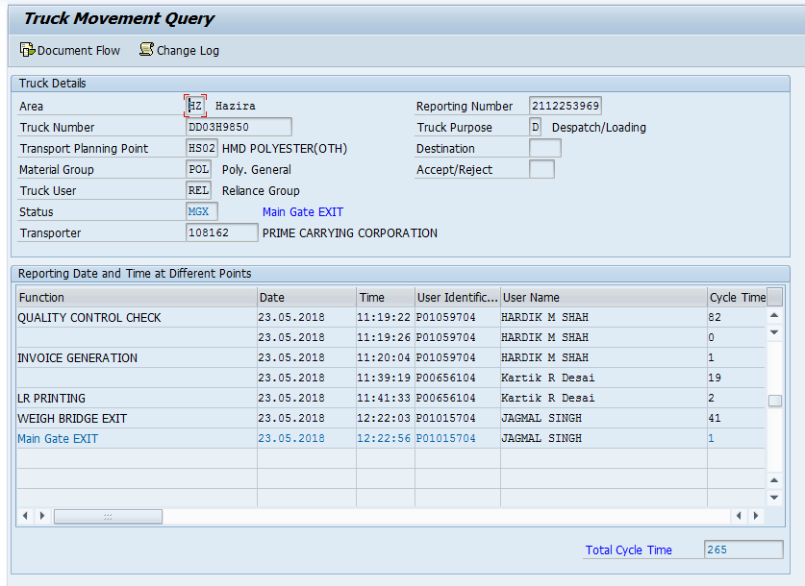

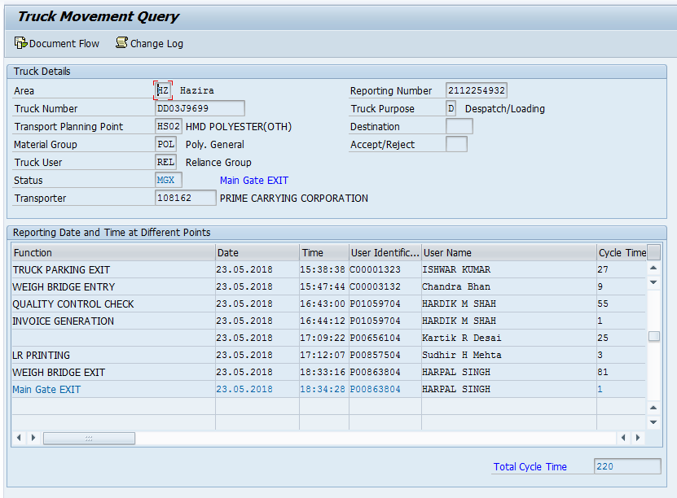

1. While dispatching 3rd shipment: 52077789 with reference to delivery: 508871357 on 24.05.2018, The user changed delivery gross weight from 16.1 MT to 0 at warehouse using ID: P01119204 (MANOJ A VYAS) on 24.05.2019 @ 09:01:59.

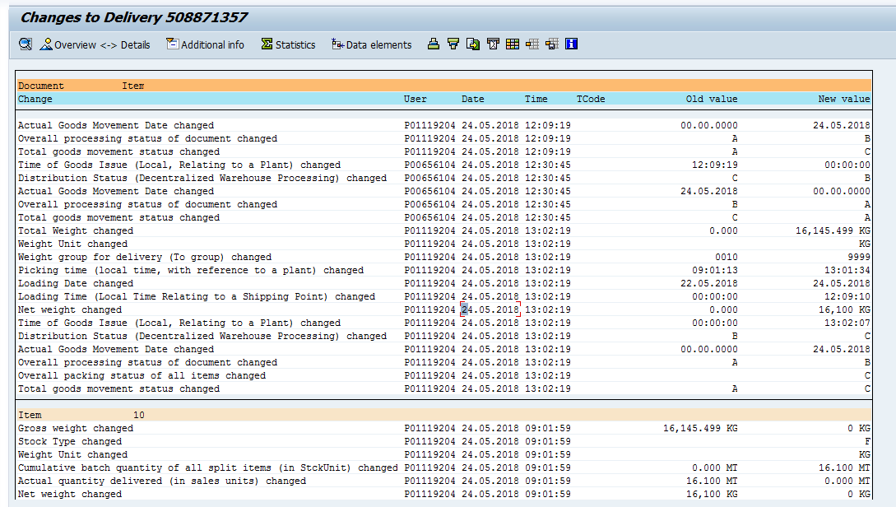

1. As soon as delivery quantity changed in delivery to 0, Schedule line quantity updated in sale order and same has been pushed in TPVS.
2. New delivery (508885781 24.05.2018, 12:55:16) and shipment (52080274 @ 24.05.2018, 13:19:23) created from TPVS using the same Sales order with the updated line item quantity.

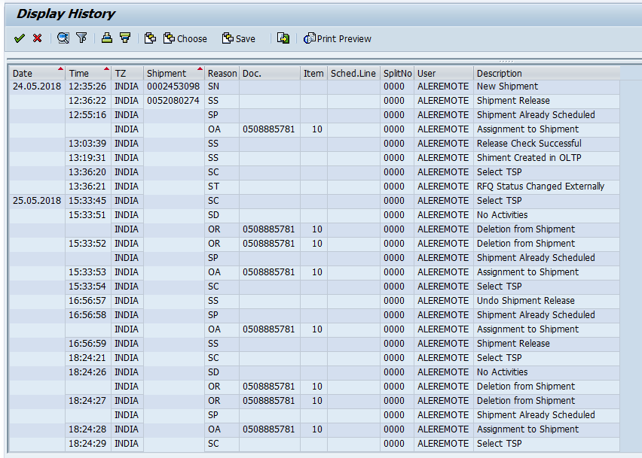

1. User ID: P01119204 (MANOJ A VYAS) again on 24.05.2019 @ 13:02:19 changed 3rd delivery quantity from 0 MT to 16.1 MT (this was made 0 earlier). **This system should not have allowed to make it 16.1 again as the SO, there is no schedule quantity left for the delivery.**

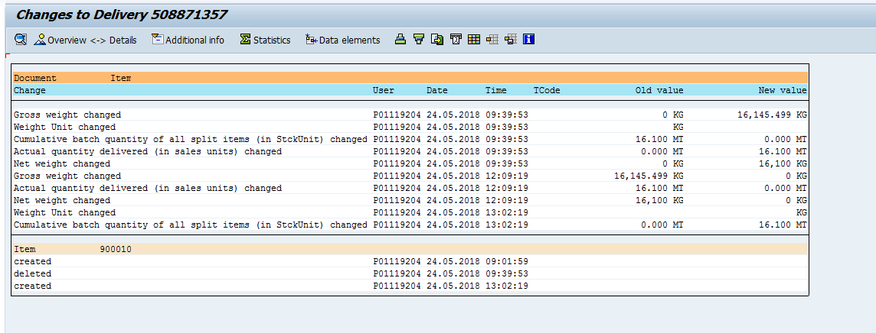

1. 3rd Shipment: 52077789 dispatched @ 24.05.2018, 14:46 with reference to reporting no: 2112255481 and 4th shipment: 52080274 dispatched @ 25.05.2018, 18:24 with reference to reporting number: 2112260121.

**Both the shipment got dispatched after billing**

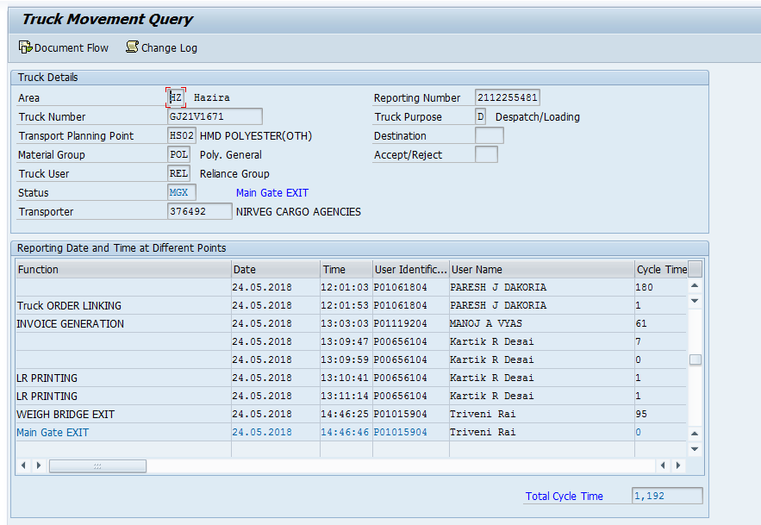

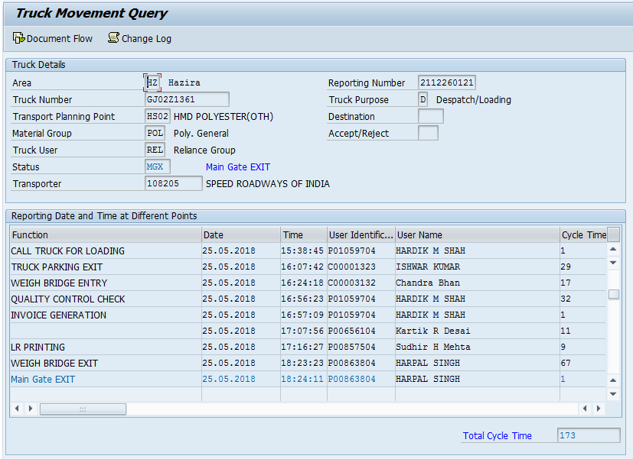

1. **OSS note # 308855 / 2018 Deliveries got created more than scheduled order quantity raised for issue.**